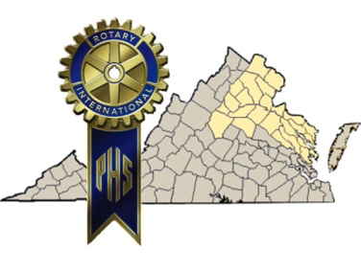
Paul Harris Society
District 7610
The Paul Harris Society (PHS) is named after the founder of Rotary International. The PHS recognizes Rotary members and friends of The Rotary Foundation who contribute US$1,000 or more each year to the Annual Fund, PolioPlus, or approved Foundation global grants. Districts administered this recognition until the Paul Harris Society became an official Rotary Foundation recognition program in July 2013. The purpose of the Paul Harris Society is to identify, engage, and thank members who have the ability and desire to make substantial annual gifts that help those less fortunate here at home and around the world. Click here for PHS FAQs
District Governor Sandy Duckworth established the District 7610 Paul Harris Society in 2002. By July 20105, the District 7610 PHS has grown to more than 225 members. It is the goal of the District to induct its 250th member by June 30, 2016.
Click here for District 7610 PHS Best Practices

Why Join the Paul Harris Society?
The Paul Harris Society provides a way for dedicated Rotarians to support the good work of The Rotary Foundation while honoring Rotary founder Paul Harris. Although the Society is not appropriate for everyone, there are many District 7610 Rotarians who are both willing and able to provide this level of support for initiatives that provide clean water and sanitation, promote basic education and literacy, improve maternal and child health and disease prevention and treatment, lead to economic and community development and conflict resolution, continue the race to eradicate polio, and fund Global Grants, Rotary World Peace Scholarships, District Grants, Global Scholarships, and Vocational Training Teams.
How to Join the Paul Harris Society
The simplest and most streamlined way to accomplish this is to click here for the PHS Membership Form. It is a writable form and instructions are easy to follow. Questions? Contact District 7610 Paul Harris Society Chair Sandy Duckworth at pdg7610@gmail.com or 540-361-1680.

